**C_Basic_Assignment_3c**

**Consider a 2D char array initialized with data as below.**

**#define MAX_LEN 80**

**char arr[][MAX_LENGTH]={“Antony:Joseph”, “Lata:Mary”, “Rajesh:Kumar”, “Joly:Akbar”};**

**Write an application with functions to perform the given operations on input array. Invoke the functions and test the application.**

**ARR/01 int getFirstNames(char arr[][MAX_LENGTH], int rowcount, char *firstnames[]);**

**should receive input array containing 'n' first name:last name pairs, where n=rowcount,**

**process each name, extract firstName, store address**

**in firstname array of pointers.**

**Ans:**

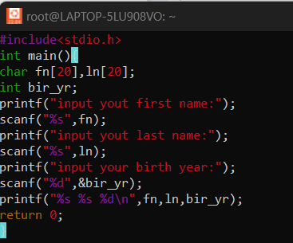

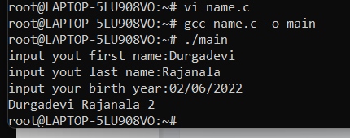

**ARR/02 int getLastNames(char arr[][MAX_LENGTH], int rowcount, char *lastnames[]);**

**Similar to getFirstName(), but it extracts and stores in lastnames**

**Ans:**

